Annual General Meeting

Bulgarian- Canadian Society of British Columbia

December 05, 2021, 17:00 pm, On-line – Zoom

Chair: Daniela Al-Kuwatli

Minutes: Vania Zaharieva-Alexieva

1. Welcome
2. Attendance and Quorum (Daniela Al-Kuwatli)

Daniela reported: we have 146 members. Vania reported: In attendance 28 people including proxies. Meeting commenced at 17:20 am.

1. Election of Meeting Chair

Daniela suggested Ivan to chair the meeting. Ivan declined. Vania suggested Daniela. All in favor.

|  |  |
| --- | --- |
| Motion and vote to approve the Daniela as a chair was presented: | Carried unanimously |

1. Acceptance of minutes of previous AGM (Vladimir Popov)

The minutes from 2021 were accepted.

|  |  |
| --- | --- |
| Motion and vote to approve the minutes as presented: | Carried unanimously |

1. Presentation of the annual report for October 2019 to December 2020 (Vladimir Popov)

Vladimir Popov - the President of the Society, presented the annual report. It was reported that the reported year October 2019 – December 2020 was a successful one. Multiple events were organized, despite the pandemic situation during that time frame. The 20th anniversary of the Society was celebrated. March 3th with was celebrated with the flag raising ceremony in New Westminster, special light shows at the Parliament of BC in Victoria and City Hall in Vancouver. Two times consular days were organized and Bulgarian elections.

|  |  |
| --- | --- |
| Motion and vote to approve the annual report as presented | Carried unanimously |

6. Financial report 2019/2020 (Vania Zaharieva-Alexieva)

Vania presented last year’s financial report. Two years financial reports (2019-20 and 2020-21) were finalized, but the report for 2019-2020 was only presented. The main income for the Society is from consular days and the main expenses are from cultural events. The organization of the cultural events and their importance for the life of the Bulgarian diaspore was discussed.

|  |  |
| --- | --- |
| Motion and vote to approve the financial report as presented | Carried unanimously |

7. Proposed bylaw amendment (Daniela Al-Kuwatli)

Lately multiple times there is no quorum at the board meetings. We have 11 board members, few of which are in Bulgaria for unknown period of time. The quorum is represented by 6 people, but often there is no more than 4. The proposed amendment is to change the bylaw for Board meetings quorum to be represented of 4 people. After discussion and consultation with the existing bylaw, the amendment was considered unnecessary, as such an option exists in the current by-law.

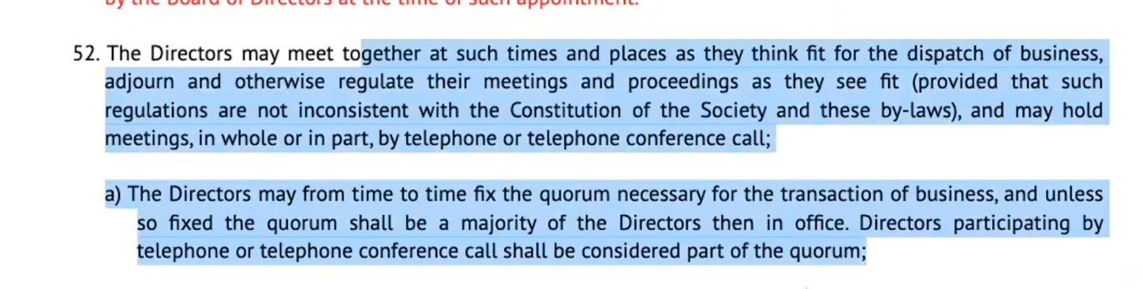

1. Election of New Board of Directors and President.

Petar Petrov, Lilya Jekova, Marina Dontcheva and Elitsa Kumanova resign as Board members. The board for 2021 -22 is: Vladimir Popov, Daniela Dobreva-Al-Kuatli, Vania Zaharieva-Alexieva, Maya Trencheva, Ivan Penev, Snezhana Ignatova, Hristo Popov.

|  |  |
| --- | --- |
| Motion and vote to approve current members roll over and elect a new member | Carried unanimously |

9. Closing the meeting and thank you remarks.

The recording of the meeting [is here:](https://ca01web.zoom.us/rec/share/9uBq4oXY6qr3Yi3l7wX0u5otYknIDIpdfA4PFgt1FteTT0ouo1DLTDKz_25O8tvm.NTlaD0qoGqb9le_u?startTime=1638753506000%20Passcode:%202Z8M3.RG)

The meeting was adjourned at 5.55 pm.